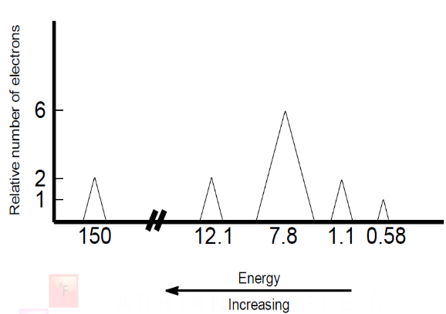
Photoelectron Spectroscopy
Plot 1

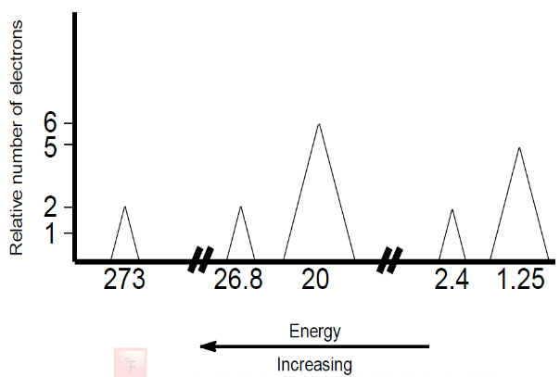
Plot 2

- Consider the simulated PES plot 1 shown above, that is produced by the analysis of the atoms of a single element. All peaks in the PES are shown.
  - Using plot 1, suggest the electron configuration of the element and hence identify the element.
  - Which two peaks are likely to represent electrons that are most likely to be removed when these atoms form ions? Explain.
  - Using your answer in (b), identify the mostly likely charge on an ion of this element. Explain.
  - Suggest a reason for the huge jump in energy between the peak at 12.1 and the peak at 150.
  - Suggest a reason for the x-axis being labeled with increasing values from right to left.
- Consider the simulated PES plot 2 shown above, that is produced by the analysis of the atoms of a single element. All peaks in the PES are shown.
  - Write the electron configuration and identify the element.
  - The plot is divided into three separate areas on the x-axis. Why is the axis divided in this manner?
  - What would be the charge on an ion formed from this atom? Justify your answer.
  - What is the significance of three of the peaks having the same height?
  - The peaks at 1.25 & 2.44, as well as the peaks at 20.2 & 26.8, are relatively close to one another but have different energies? Explain why they are of the same magnitude but slightly different.
- Consider a PES plot for carbon atoms.
  - How many peaks would you expect in the PES for carbon? Explain.
  - What would be the relative heights of the peaks that you have identified in (a)? Explain your answer carefully.
  - How would you expect the height of the 2p peak in carbon’s PES to compare to the height of the 2p peak in nitrogen’s PES? Explain.

