**Flame Test and Electron Configuration Lab**

**Introduction:**

Back in the 18th century, chemists began using flame tests to identify and distinguish elements. Different elements produce different colored flames when placed in the fire of a Bunsen burner. The different colors of flames are produced by electrons moving between energy levels and are useful in identifying an element.

The origin of this phenomenon lies in the arrangement, or “configuration” of the electrons in the atoms of the different elements. In the “solar system” model of the atom first proposed by Ernest Rutherford and Niels Bohr in the early 1900s, the electrons were pictured as moving around the nucleus in circular orbits in a similar manner that the planets in our solar system orbit the sun. As envisioned by Bohr, during heating, one or more electrons may absorb energy in sufficient amounts to “jump” to an orbit farther away from the nucleus. Since the electron has a higher potential energy in its new orbit, the electron is said to be in a higher *energy level*. When the electron has been promoted to a higher energy level, the atom is said to be in an ***excited state*.**

At some point, the electrons will lose that excess energy and fall back to their lower, ground state energy level. It is the emission of this excess energy that results in the colored bands on the atomic line spectra. Each colored line represents a transition between a particular pair of energy levels. For example, a red line might indicate a transition between energy levels 2 and 3 whereas a violet line may indicate a transition between energy levels 2 and 6. The energy of these lines can be calculated from their wavelengths and will give us a picture of how the different energy levels are structured within the atom.

When the electrons drop from a higher energy level to a lower energy level (in an orbit closer to the nucleus), energy is released. In the flame test, if this energy has the form of visible light, the flame will produce a color characteristic of the element. Different elements have a unique color in its flame which can be used to identify an element. When the electrons are in their lowest energy orbits (closest to the nucleus), the atom is said to be in its ***ground state*.**

**Purpose:**

In this lab, you will investigate the characteristic flame color and spectral lines produced by solutions of different metal ions. You will need to make careful, descriptive observations of the colors and then use those descriptions to identify the unknown samples.

**Pre-Lab Exercises:**

1. Write electron configuration for the alkali metals; Li, Na, K, and Rb.
2. Write the electron configuration for strontium and the strontium metal ion.
3. Name the colors in visible light, beginning with that of highest energy.
4. What is the maximum number of electrons that the first 4 principle energy levels will hold?
5. Complete the following table of information:

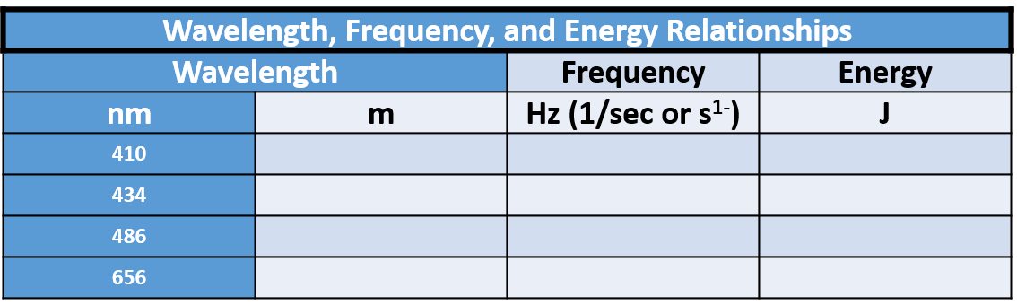

1. Based on the information calculated in the table in question #5, please identify the appropriate wavelength for each electron excitation diagrammed below:





**Procedure:**

1. Set up a Bunsen burner and correctly adjust the flame until two blue cones are visible. Have your teacher check this to make sure you have done this correctly before moving on.
2. Each metal that we will test in the lab is separated in an individual cup/beaker and has a corresponding cup/beaker of water. PLEASE BE CAREFUL NOT TO MIX UP THE WOOD SPLINTS. MAKE AN EXTRA EFFORT TO KEEP THE ORIGINAL PAIRINGS TOGETHER!
3. Remove the wood splint from the water, shake it off and then dip it into the metal salt. You want a few of the crystals to stick to the end of the wet splint.
4. Immediately place the splint into the peak of the inner blue flame for no more than 5 seconds. If you would like to repeat the color, rinse the wood splint in the water and then repeat steps 3 and 4.

**Data table:**

|  |  |  |  |  |  |  |
| --- | --- | --- | --- | --- | --- | --- |
| **Metallic Salt** | **Metal ion** | **Color** |  | **Metallic Salt** | **Metal Ion** | **Color** |
| Unknown #1 |  |  |  | Unknown #4 |  |  |
| Unknown #2 |  |  |  | Unknown #5 |  |  |
| Unknown #3 |  |  |  |  |  |  |

**Post Lab:**

Wavelength ranges for visible spectrum light:

**Violet:** 380 - 450 nm

**Blue:** 450 – 496 nm

**Green:** 495 - 570 nm

**Yellow:** 570 – 590 nm

**Orange:** 590 - 620 nm

**Red:** 620 – 750 nm

Please estimate the wavelength for each color of light observed in the experiment and then calculate an energy and a respective frequency.

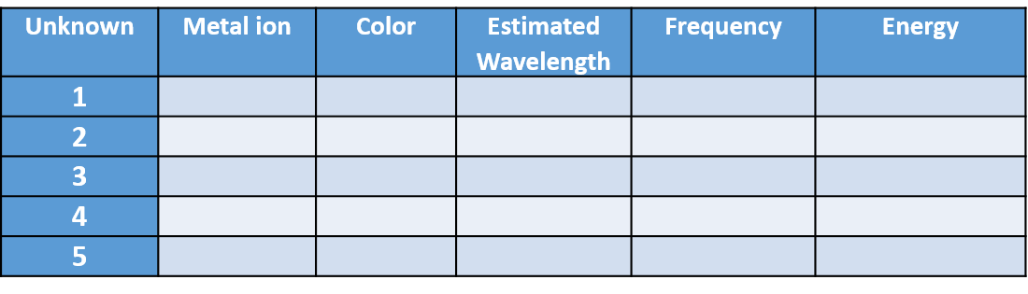

1. Write a generalization relating the number of energy levels an electron “falls” to the energy of the photon associated with such a move.
2. In addition to the Balmer series (shown below) in the visible region, hydrogen atoms also produce a series in the ultraviolet region (Lyman series) and the infrared region (Paschen series). Consider the following:

* An electron transitioning between *n* = 1 and *n* = 2 has a wavelength of 122 nm.
* An electron transitioning between *n* = 2 and *n* = 3 has a wavelength of 656 nm.
* An electron transitioning between *n* = 3 and *n* = 4 has a wavelength of 1875 nm.

Given that all of these transitions involve only a single energy level difference, what can be inferred about the distance separating energy levels as you move farther away from the nucleus?

