Atomic Theory: Who were the scientists, and what experiments did they perform to shape our current understanding of what an atom “looks like”?

Dalton (1766-1844) - Dalton began the development of modern atomic theory including his postulates.

He was a British school teacher and published his theory about atoms in 1808. His findings were based on experiments and the laws of chemical combination.

1) All matter is made of atoms. Atoms are indivisible and indestructible.

2) All atoms of a given element are identical in mass and properties

3) Compounds are formed by a combination of two or more different kinds of atoms.

4) A chemical reaction is a rearrangement of atoms.

Drawbacks of Dalton's atomic theory of matter
- The indivisibility of an atom was proved wrong: an atom can be further subdivided into protons, neutrons and electrons. However an atom is the smallest particle that takes part in chemical reactions.
- According to Dalton, the atoms of same element are similar in all respects. However, atoms of some elements vary in their masses and densities. These atoms of different masses are called isotopes. For example, chlorine has two isotopes with mass numbers 35 and 37.
- Dalton also claimed that atoms of different elements are different in all respects. This has been proven wrong in certain cases: argon and calcium atoms each have an atomic mass of 40 amu. These atoms are known as isobars.
- According to Dalton, atoms of different elements combine in simple whole number ratios to form compounds. This is not observed in complex organic compounds like sugar (C₁₂H₂₂O₁₁).
- The theory fails to explain the existence of allotropes; it does not account for differences in properties of charcoal, graphite, diamond.

Merits of Dalton's atomic theory
- The atomic theory explains the laws of chemical combination.
- Dalton was the first person to recognize a workable distinction between the fundamental particle of an element (atom) and that of a compound (molecule).

Sir Joseph John "J. J." Thomson, (1856 – 1940)
He is credited for the discovery of the electron and of isotopes, and the invention of the mass spectrometer. Thomson was awarded the 1906 Nobel Prize in Physics for the discovery of the electron and for his work on the conduction of electricity in gases.
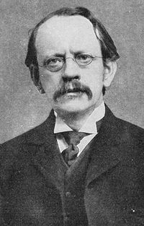
(1900)Plum pudding model was hypothesized by J.J. Thomson who described an atom as being a large positively charged body that contained small, free-floating, negatively charged particles called electrons.

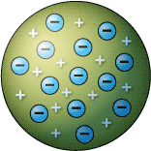

Thomson’s Cathode Ray Experiments
- Look at any glowing neon sign and you are looking at the modern descendants of the cathode ray tube.
- Do atoms have parts? J.J. Thomson suggested that they do. He advanced the idea that cathode rays are really streams of very small pieces of atoms. Three experiments led him to this.
- Thomson built a cathode ray tube ending in a pair of metal cylinders with a slit in them. These cylinders were in turn connected to an electrometer, a device for catching and measuring electrical charge. He found that when the rays entered the slit in the cylinders, the electrometer measured a large amount of negative charge.

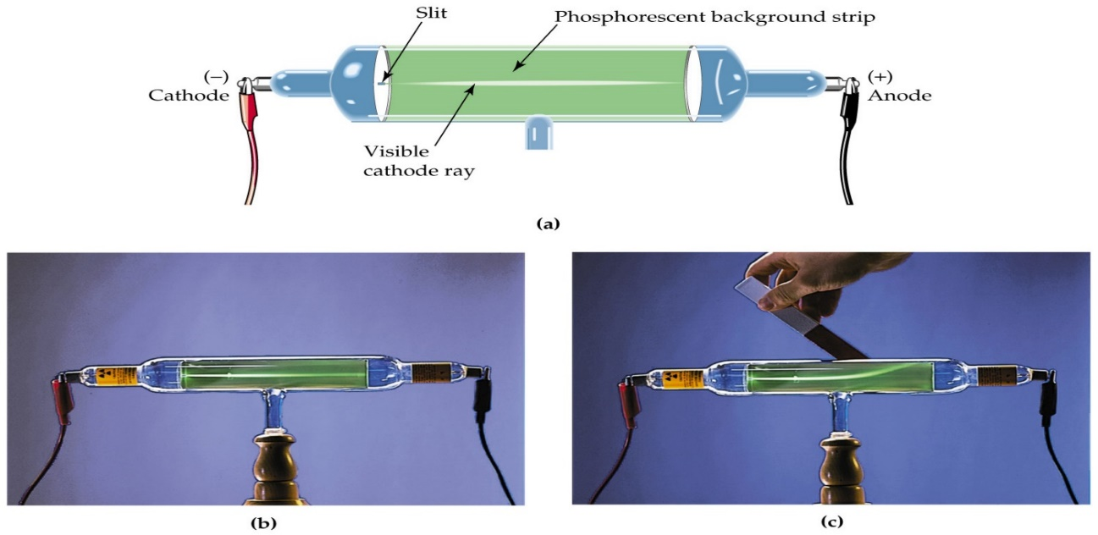

Rutherford (1871 – 1937)

He was a British chemist and physicist who became known as the father of nuclear physics.
(1910)
- Rutherford’s team identified the Positive atomic nucleus using the gold foil experiment.
- Rutherford’s team later discovered the proton and neutron.

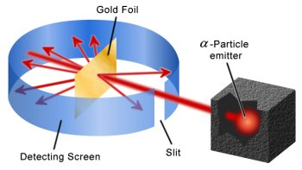

Rutherford’s experiment explained…

Imagine shooting a gun at a piece of paper… what would you expect to happen?

How would you explain if the bullets went straight through…

This is what was expected. Bullets are massive compared to the paper and travelling at incredibly high speeds.

How would you explain bullets ricocheting off to the left or right….

The bullets hit “something” that was massive enough to deflect it. This was a very suprising finding and showed evidence for a MASSIVE part of the atom. The current model, the “Plum Pudding” model did not account for this data

How would you explain bullets bouncing back….

Completely unexpected! The alpha particles are charged particles and the fact that they bounced back meant that they hit something massive that was also positively charged. This led to the discovery of the positively charged, dense nucleus!

Niels Bohr (1885 –1962) was a Danish physicist who made fundamental contributions to understanding atomic structure and quantum mechanics, for which he received the Nobel Prize in Physics in 1922.
(1913)
- Bohr developed the planetary model of the atom, Bohr model.
- The atom has a small, positively charged nucleus surrounded by electrons that travel in circular orbits around the nucleus

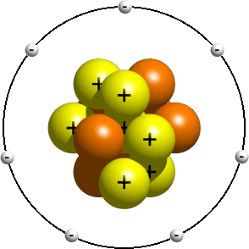

THE HISTORY OF THE PERIODIC TABLE
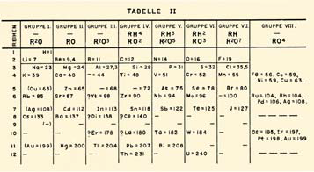
1800ish—Johann Dobereiner, triads; 1864 John Newlands octaves; 1870--Dmitrii Mendeleev & Julius Lothar Meyer--by mass; 1913 Mosley--by number of protons.

During the nineteenth century, chemists began to categorize the elements according to similarities in their physical and chemical properties. The end result of these studies was our modern periodic table.

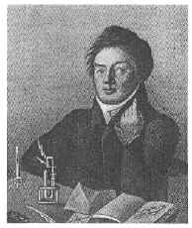
Johann Dobereiner - In 1829, he classified some elements into groups of three, which he called triads.The elements in a triad had similar chemical properties and orderly physical properties.

Dobereiner’s Model of triads

Examples: Cl, Br, I and Ca, Sr, Ba

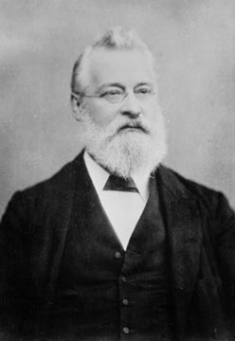
John Newlands - In 1863, he suggested that elements be arranged in “octaves” because he noticed (after arranging the elements in order of increasing atomic mass) that certain properties repeated every 8th element.

Newlands’ Law of Octaves

Newlands' claim to see a repeating pattern was met with savage ridicule on its announcement. His classification of the elements, he was told, was as arbitrary as putting them in alphabetical order and his paper was rejected for publication by the Chemical Society.

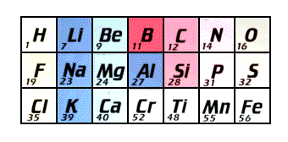

His law of octaves failed beyond the element calcium… Based on what we know today WHY????

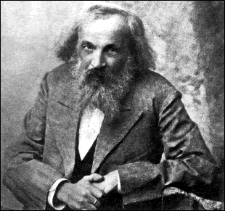
Dmitri Mendeleev -

In 1869 he published a table of the elements organized by increasing atomic mass.

Lothar Meyer - At the same time, he published his own table of the elements organized by
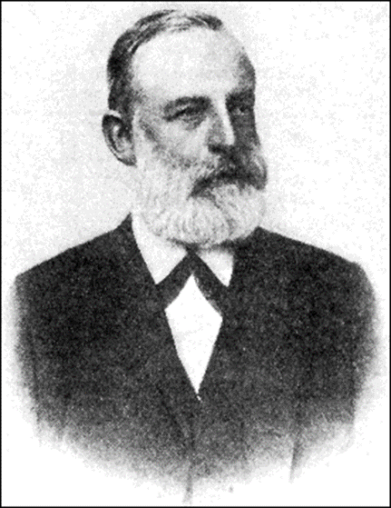
increasing atomic mass.

- Both Mendeleev and Meyer arranged the elements in order of increasing atomic mass.
- Both left vacant spaces where unknown elements should fit.

So why is Mendeleev called the “father of the modern periodic table” and not Meyer, or both?

Mendeleev…
- stated that if the atomic weight of an element caused it to be placed in the wrong group, then the weight must be wrong. (He corrected the atomic masses of Be, In, and U)
- was so confident in his table that he used it to predict the physical properties of three elements that were yet unknown.
  - After the discovery of these unknown elements between 1874 and 1885, and the fact that Mendeleev’s predictions for Sc, Ga, and Ge were amazingly close to the actual values, his table was generally accepted.

However, in spite of Mendeleev’s great achievement, problems arose when new elements were discovered and more accurate atomic weights determined. By looking at our modern periodic table, can you identify what problems might have caused chemists a headache?

For example: Ar and K

Co and Ni

Te and I

Th and Pa

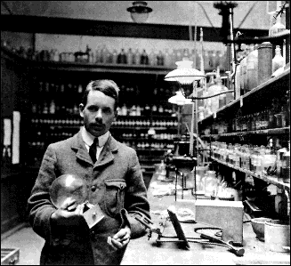
Henry Moseley - In 1913, through his work with X-rays, he determined the actual nuclear charge (atomic number) of the elements*. He rearranged the elements in order of increasing atomic number.

Moseley stated: *“There is, in the atom, a fundamental quantity which increases by regular steps as we pass from each element to the next. This quantity can only be the charge on the central positive nucleus.”

His research was halted when the British government sent him to serve as a foot soldier in WWI. He was killed in the fighting in Gallipoli by a sniper’s bullet, at the age of 28. Because of this loss, the British government later restricted its scientists to noncombatant duties during WWII.

Glenn T. Seaborg -
After co-discovering 10 new elements, in 1944 he moved 14 elements out of the main body of the periodic table to their current location below the Lanthanide series. These became known as the Actinide series.
