Historical Development of the Model of the Atom and the Periodic Table.
- What were Dalton’s 4 postulates?

1) All matter is made of atoms. Atoms are indivisible (proven wrong) and indestructible.

2) All atoms of a given element are identical in mass (proven wrong due to isotopes) and properties

3) Compounds are formed by a combination of two or more different kinds of atoms.

4) A chemical reaction is a rearrangement of atoms.

- What was the experimental set-up of JJ Thomson (Draw it and describe what was going on)? What was the name of the experiment?

CATHODE RAY TUBE- Thomson built a cathode ray tube ending in a pair of metal cylinders with a slit in them. These cylinders were in turn connected to an electrometer, a device for catching and measuring electrical charge. He found that when the rays entered the slit in the cylinders, the electrometer measured a large amount of negative charge.

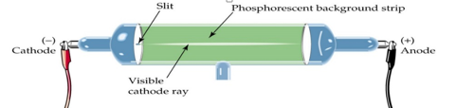

- What two major discoveries did Thomson make using the cathode ray experiment?
Electrons and isotopes

- What was the experimental set-up of Rutherford’s experiment (draw it and describe what was going on)? What was the name of the experiment?
GOLD FOIL EXPERIMENT- alpha particles are shot at a piece of gold foil and then detected by the detecting screen. Most pass straight through but some bounced back or to the side.
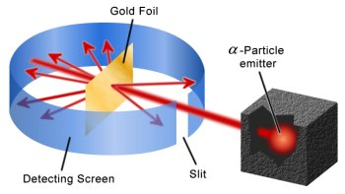

- The gold foil experiment resulted in two major discoveries which were made about the structure of the atom. What were they
The gold foil experiment discovered that there was a large mass in the center and that it was positively charged… So he discovered a dense positively charged nucleus.

- Draw below the model of the atom proposed be the following individuals

Dalton (1800)
Thomson (1897)
Rutherford (1910)
Bohr (1913)

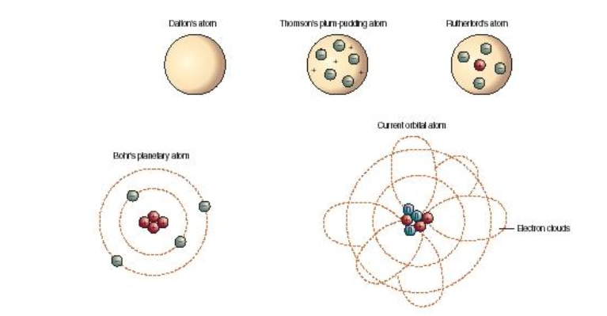

- How did Thomson’s model differ from Dalton’s model?
Dalton thought that atoms were the smallest form of matter so he believed tat they would be hard spheres like a billiard ball. Thomson believed that there were smaller particles like electrons and protons. He believed atoms were composed of protons sprinkled within the electrons like chocolate chips in a cookie.

- Who is credited with developing the first periodic table? It was arranged by mass and not atomic number, explain why based on the timeline of discoveries.
Dmitri Medeleev created the first periodic table arranged by atomic mass. (not atomic number) Mendeleev created his table in 1869 and subatomic particles were not discovered until until Thompson found the electron in 1897.

- Who is the “Father” of the modern periodic table? How is the current periodic table arranged?
Mendeleev is the “father” of the modern periodic.

The Current periodic table is arranged by atomic number. The scientist who determined the nuclear charge of elements was Henry Moseley

- Make a timeline sketch of experiments and discoveries.

