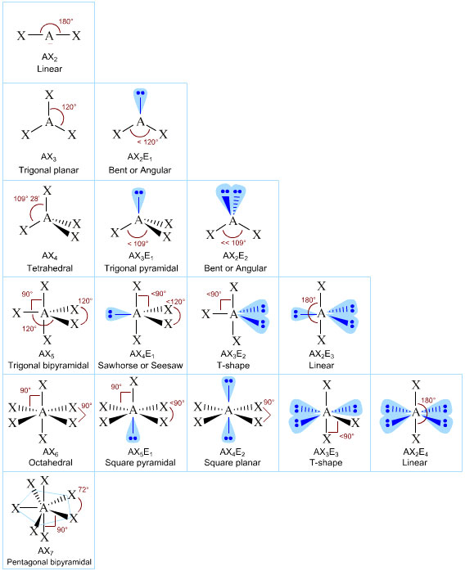**Molecular Geometries**

**You will need to memorize:**

* Molecular geometry
* Bond angles
* AXE designations

**A =** Central atom (atom in the middle)

**X =** Bonding pairs of electrons (line and hashed lines)

**E =** Lone Pairs of Electrons (pairs of dots)