Unit 03 - In-class Review

Choose the best answer from the options that follow each question.

____ 1. Neutral atoms contain equal numbers of
a. | electrons and neutrons.
b. | protons and neutrons.
c. | protons and electrons.
d. | protons, electrons, and neutrons.

____ 2. Rutherford’s gold-foil experiment led him to conclude that
a. | Thomson’s plum pudding model of the atom was accurate.
b. | alpha particles were a poor choice for a bombardment material.
c. | a dense region of positive charge existed somewhere in the atom.
d. | light was emitted by electrons returning to ground state.

____ 3. The isotope uranium-235 has 92 protons and 143 neutrons. Therefore, its mass number is
a. | 92.
b. | 235.
c. | 143.
d. | impossible to determine.

____ 4. What is the frequency of light whose wavelength is 633 nm?
a. | 4.74 10⁻⁴ Hz
b. | 4.74 10⁻² Hz
c. | 4.74 10¹⁴ Hz
d. | 4.74 10¹⁶ Hz

____ 5. What is the frequency of a photon whose energy is 3.4 10⁻¹⁹ J? (h = 6.626 10⁻³⁴ J•s)
a. | 8.8 10²⁶ Hz
b. | 5.1 10¹⁴ Hz
c. | 1.9 10⁻¹⁵ Hz
d. | 2.3 10⁻⁵² Hz

Use the periodic table below to answer the questions in this Chapter Test.
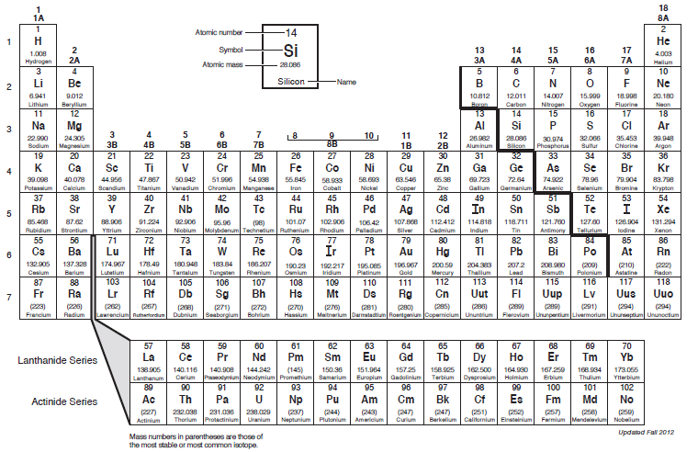

____ 6. Mendeleev organized the chemical elements based on their
a. | symbols.
b. | atomic mass.
c. | atomic numbers.
d. | charges.

____ 7. Which of the following elements has the greatest atomic radius?
a. | Al
b. | S
c. | Si
d. | C

____ 8. Which of the following elements has the lowest electronegativity?
a. | C
b. | F
c. | Li
d. | O

____ 9. Which of the following elements has the greatest ionization energy?
a. | Ga
b. | K
c. | Bi
d. | As

____ 10. In his periodic table, Mendeleev listed all of the elements in order of increasing atomic mass and also grouped them according to similar:
a. | properties.
b. | atomic numbers.
c. | isotopes.
d. | charges.

____ 11. A new group was added to Mendeleev’s periodic table after the discovery of
a. | alkali metals.
b. | electrons.
c. | noble gases.
d. | atomic nuclei.

____ 12. Moseley discovered that elements with similar properties occurred at regular intervals when the elements were arranged in order of increasing
a. | atomic mass.
b. | density.
c. | radioactivity.
d. | atomic number.

____ 13. Determine the number of protons, neutrons and electrons in the following:
X
a. | p+ = 18 n° = 18 e⁻ = 22
b. | p+ = 18 n° = 22 e⁻ = 18
c. | p+ = 22 n° = 18 e⁻ = 18
d. | p+ = 18 n° = 22 e⁻ = 40
e. | p+ = 40 n° = 22 e⁻ = 18

____ 14. What species is represented by the following information?

p⁺ = 12 n° = 14 e⁻ = 10
a. | Si⁴⁺
b. | Mg
c. | Ne
d. | Si
e. | Mg²⁺

____ 15. Calculate the atomic mass of silver if silver has 2 naturally occurring isotopes with the following masses and natural abundances:

Ag-107 106.90509 amu 51.84%
Ag-109 108.90476 amu 48.46%
a. | 107.90 amu
b. | 108.00 amu
c. | 107.79 amu
d. | 108.32 amu
e. | 108.19 amu

____ 16. Calculate the atomic mass of element "X", if it has 2 naturally occurring isotopes with the following masses and natural abundances:

X-45 44.8776 amu 32.88%
X-47 46.9443 amu 67.12%
a. | 46.26 amu
b. | 45.91 amu
c. | 46.34 amu
d. | 46.84 amu
e. | 44.99 amu

____ 17. Calculate the wavelength (in nm) of the blue light emitted by a mercury lamp with a frequency of 6.88 × 1014 Hz.
a. | 229 nm
b. | 436 nm
c. | 206 nm
d. | 485 nm
e. | 675 nm

____ 18. Calculate the energy of the red light emitted by a neon atom with a wavelength of 703.2 nm.
a. | 3.54 × 10⁻¹⁹ J
b. | 4.27 × 10⁻¹⁹ J
c. | 2.34 × 10⁻¹⁹ J
d. | 6.45 × 10⁻¹⁹ J
e. | 2.83 × 10⁻¹⁹ J

____ 19. Place the following in order of increasing atomic radius.

 | As | O | Br

a. | As < Br < O
b. | O < As < Br
c. | Br < As < O
d. | As < O < Br
e. | O < Br < As

____ 20. Experiments with cathode rays led to the discovery of the
a. | proton. | c. | neutron.
b. | nucleus. | d. | electron.

____ 21. The deflection of cathode rays in Thomson's experiments was evidence of the ____ nature of electrons.
a. | wave | c. | particle
b. | charged | d. | spinning

____ 22. Whose series of experiments identified the nucleus of the atom?
a. | Rutherford | c. | Chadwick
b. | Dalton | d. | Bohr

____ 23. The discovery of what elements added a new column to Mendeleev's periodic table?
a. | noble gases | c. | transition elements
b. | radioactive elements | d. | metalloids

